Jacob Nye

BMEN 4840 Functional Imaging of the Brain

Final Report: ICA-based Motion Correction

        In functional imaging studies, different sources of noise pose different problems in interpreting the hemodynamic response of the brain and thus the neuronal activation in response to a given task. These sources of noise are often hard to distinguish from signal, because the BOLD response is typically 5% of the total signal or less and noise can be much greater than this, especially motion-based artefacts. This can make it a challenge during neuroimaging studies to draw conclusions since significant preprocessing must be performed to remove as much noise as possible. While software packages such as FSL and SPM attempt to estimate the motion parameters during registration and correct this source of noise, it has been shown that a lot of motion-based noise remains after this and that the data can be improved through further processing steps. One procedure that has gained popularity in recent years for improving the removal of noise has been a statistical approach independent component analysis (ICA), which assumes that fMRI data consist of a set of spatially overlapping signal each with an independent spatial pattern and a unique time course. In spatial ICA, the emphasis is on spatial independence that minimizes the redundancy in the spatial maps of the components whereas temporal ICA minimizes redundancy in the time courses of the components. The application of independent component analysis can have a great effect on the outcomes of the results. Since ICA ban be used to identify sets of voxels with similar BOLD fluctuations over time, it can be used to identify and remove components whose temporal or spatial properties imply that they reflect task-related noise. This separation of components is done blindly, so ICA is considered a solution to the blind source separation problem. Examples of spatial distributions that imply a component or sets of components are noise include a spatial distribution outside of grey matter, ringlike patterns of signal, oscillations at high frequencies, and irregular clustering of signal (Huettel et. al). Ideal cleaning procedures minimize the extraneous noise-related signals and increase the significance and specificity of the active regions in the brain and improve SNR. It is this improvement and reduction of noise that is attempted with this project by using ICA-based motion correction techniques as an additional processing step during the analysis.

For conducting the spatial ICA-based motion correction, FSL was used to conduct the analysis for the 35 patients in the study. The subprogram MELODIC was used to extract the spatial independent components, and each patient was had his fMRI data imported into the program with a TR set to 2 s, and a high pass filter cutoff of 100 s was used as the longest temporal period allowed. Motion correction was performed for each patient using MCFLIRT, slice timing correction was performed using a slice time file created that matched the slice timing given in the lab sessions, spatial smoothing was performed with a FWHM of 5 mm, and high pass temporal filtering was performed to remove low frequency artefacts. Registration was then performed between the functional images and the high resolution T1 structural image using linear normal search with 12 degrees of freedom (DOF), and then was registered to standard space using the MNI152 2mm brain standard using linear normal search using 12 DOF and 4 mm resampling resolution. Each patient’s functional data had variance-normalization of its time courses to reduce the influence of its mean signal on the signal’s estimation and increase the influence of its voxel-wise temporal dynamics, as well as automatic dimensionality estimation using single session ICA in MELODIC. The independent component maps were thresholded using a threshold of 0.5. The output from MELODIC was then input into ICA-AROMA to classify the independent components as motion-based noise or not, and the output of ICA-AROMA of the denoised functional brain scans using non-aggressive partial component regression was input into FEAT for the statistics section of first level analysis. The GLM for each patient was set up for three EVs, visual, audio, and motion, using the full model setup, and the time courses, duration, and value (1) was extracted from the spm.mat file for each patient and input using the custom 3-column format for shape. The convolution function used for each EV was the double-gamma HRF and FILM prewhitening was used for each patient’s statistics. The settings for the post-stats of each patient was voxel-based thresholding with a corrected voxel P threshold of 0.05 so that it could be compared to the previous SPM analysis conducted without spatial ICA motion correction. The time series plots were also extracted.

        From the first level analysis, it appears that the ICA-AROMA based motion correction had mixed performance, with the results indicating that some patients had signal recovered that was missed in the presence of motion artefacts and other patients had both the motion artefacts and signal remove because of an overly aggressive independent component signal removal that removed as many as 57 of  59 independent components. An example of this overcleaning can be seen in figures 1 and 2, which compare the previous studies SPM results from patient 48 to the FSL ICA-based motion correction results. However, while the auditory activation was wiped out by the motion correction, the visual activation in the brain that was able to be detected appears to have increased as a result of the removal of motion-based noise, with 17 distinct clusters of voxels being present compared to 2 distinct clusters in the original SPM analysis.  This increase in visual activation is seen in several patients (e.g., patients 48, 38, 45), which would suggest that false activation caused by motion artefacts masked a significant amount of the visual activation in the hemodynamic response of the brain during the experiment. In patients that had significant visual and/or auditory activation present in the initial SPM analysis without any motion contrast activation, this activation remained and presented in the brain with a similar activation pattern after the ICA-based motion correction (figure 3a-f). This sustained activation after ICA-based motion correction contrasts several patients who had significant activation removed from the brain scans when there was significant clusters of motion-based activation, as demonstrated as activation in the original motion contrasts from the SPM analysis. For these patients, such as patients 26, 27, 33, different levels of activation patterns were removed, suggesting the classification of motion-based artefacts performs better on some patients than others. The ICA-motion correction removed all activation and signal from patient 26 (Figure 4a-f), which included both visual and motion based activation but not auditory activation. The motion activation was present in approximately the same areas that the visual activation presented, so the removal of the visual activation may have been correct since it could have been caused completely by motion-based noise. The activation patterns of patient 27 after ICA-based motion correction provide further evidence that the motion ICA-based artefact removal was effective for some patients. While patient 27 had at least one cluster of motion-based activation in the motion contrast of the original SPM first level analysis as well as visual contrast activation in the visual cortex, only the visual contrast activation remained after the motion correction (Figure 5a-g) and it appeared the visual activation increased after which would suggest the motion noise masked the original visual hemodynamic response (38 clusters after ICA-motion correction vs. 10 before). In contrast to patients 26 and 27, patient 33 had activation present in its original SPM visual, auditory, and motion contrast and after ICA-motion correction only the visual activation remained (Figure 6a-f). While the AROMA ICA-motion correction was able to remove the motion artefacts from the functional brain scans, it also removed the auditory activation signal, which meant it had classified too many independent components as motion-based noise and removed them. The number of spatial independent components that remained after AROMA ICA in patient 33 was 8 out of 51, which was less than the 17 out of 53 components that remained for patient 27 and 11 out of 43 components for patient 26. These results, along with a general pattern observed with the rest of the patients, demonstrates that the performance of the AROMA ICA motion correction drops significantly when less than 10 of the spatial components are left after the motion component classification and denoising procedure are completed. However, after observing the motion contrast from the original SPM analysis, it appears that the motion activation was present in the same regions as the auditory cortex, which would explain why the removal of motion-based noise would remove the auditory signal activation in the auditory contrast. Consistent with previous results, patient 33 had an increase in the number of clusters of significant activation in the visual contrast, with 28 clusters after AROMA ICA-based motion correction compared to 3.

While the first level analysis of the denoised data was useful for getting a better understanding of how ICA-based motion correction affects the hemodynamic activation signals on a per patient basis, group level analysis is necessary for understanding how the AROMA ICA-based motion artefact removal affects the activation levels present across the group. The feat directories were input into the higher level analysis feat to perform a group level analysis, and the Mixed Effects: FLAME 1 analysis option was used, first with corrected voxel level thresholding of P = 0.05 without outlier deweighting, and then I performed the on the same FEAT directories but with cluster based thresholding of Z=2.1 and cluster P threshold of 0.05 with outlier deweighting. The results of the original voxel thresholded analysis yielded no significant clusters in any of the three contrasts. A likely cause of this loss of significance was that the registrations and alignment of the patient’s brains to the standard was poor, and can be observed in figure 7a-b. This poor alignment would suggest that there either was an error in the alignment procedure that did not occur during the original SPM analysis or that there was an over-removal of non-motion based activation and signal that caused the brains to not match up with the alignment templates anymore. The main areas affected by the misalignment of the brain scans to the MNI152 standard were the posterior portions of the brain, which is where the visual cortex is located. The auditory cortex areas appeared to be less affected by the misalignment. In the cluster thresholded group analysis, there were clusters of significant activation among the group in all three contrasts (figure 8c-e). However, upon visual inspection of these clusters of activation, only the auditory signal activation was realistic because it occured in the auditory cortex and was present in the same areas that were activated in the first level analysis. The visual contrast activation patterns occured in regions other than the visual cortex, and there was significant motion activation at the group level that wasn’t observed at the individual level. These differences between the visual, auditory, and motion activations can be explained by the registration of the brain scans, which at a group level were mostly aligned in the regions that contained the auditory cortex but were misaligned in the regions that contained the visual cortex and the motor cortex (figure 7a-b). If brains weren’t misaligned relative to each other, this would suggest that the ICA AROMA motion-correction procedure caused spurious activation to be present. Since the alignment of the brains to the standard was poor, it’s difficult to draw any conclusions at the group level in terms of how the ICA-based motion correction affected the group analysis. It seems like the auditory effects were left intact because there are a similar number of activated clusters as there were before.

I was not able to complete the temporal ICA analysis since I could not get the R package to work on my computer in the time that the project was due, so I cannot compare the effects to spatial ICA-based motion correction. I would expect that the temporal ICA would be allow for the removal of the motion-based noise caused by respiration since it is temporal distinct and has a frequency less than 0.25 Hz given. I would not expect to be able to remove the motion-based noised caused by the beating of the heart because its frequency is above the Nyquist criterion for a TR of 2 s. Another contingency I’d have to deal with is that there are more spatial points (voxels) than time points so to perform temporal ICA I’d had to reduce the number of voxels I’m analyzing. This could be achieved using PCA first to perform dimensionality reduction before performing the temporal ICA because without the reduction of voxels being analyzed, then the ICA would work.

Works Cited

Huettel, Scott A., et al. *Functional Magnetic Resonance Imaging*. Sinauer, 2014.

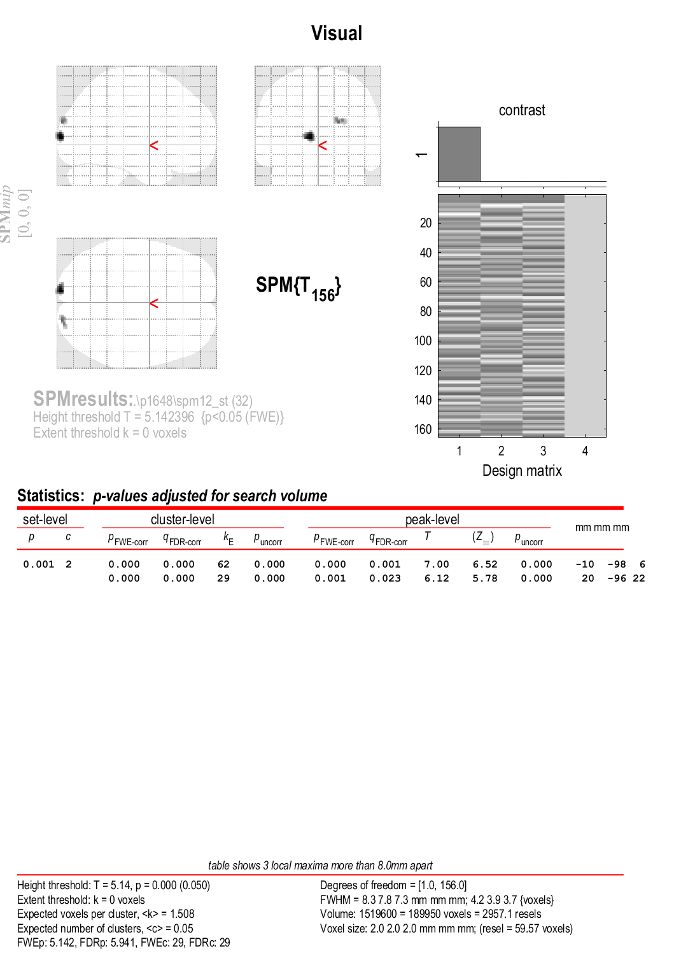

Figure 1a. Visual Activation during Normal 1st Level Analysis (Patient 48)

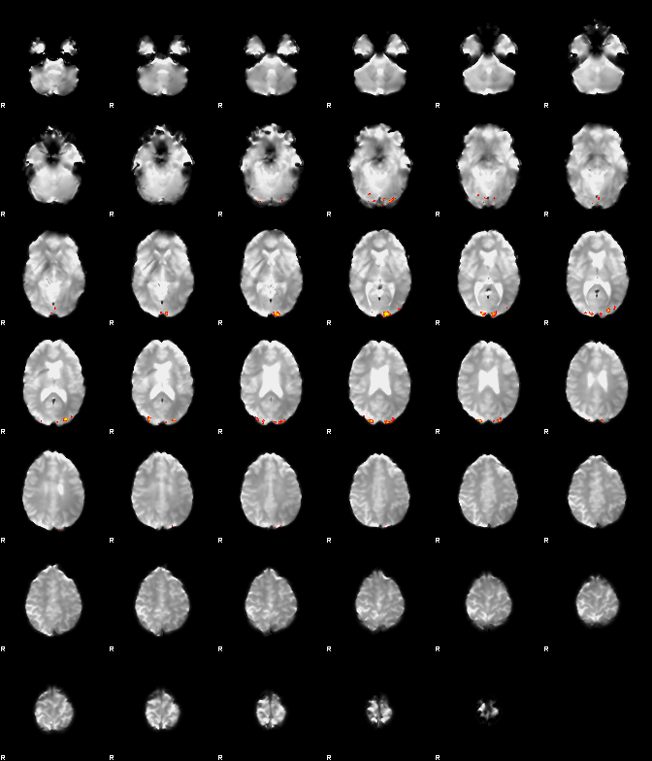

Figure 1b. Visual Activation after ICA-AROMA Motion Correction (Patient 48)

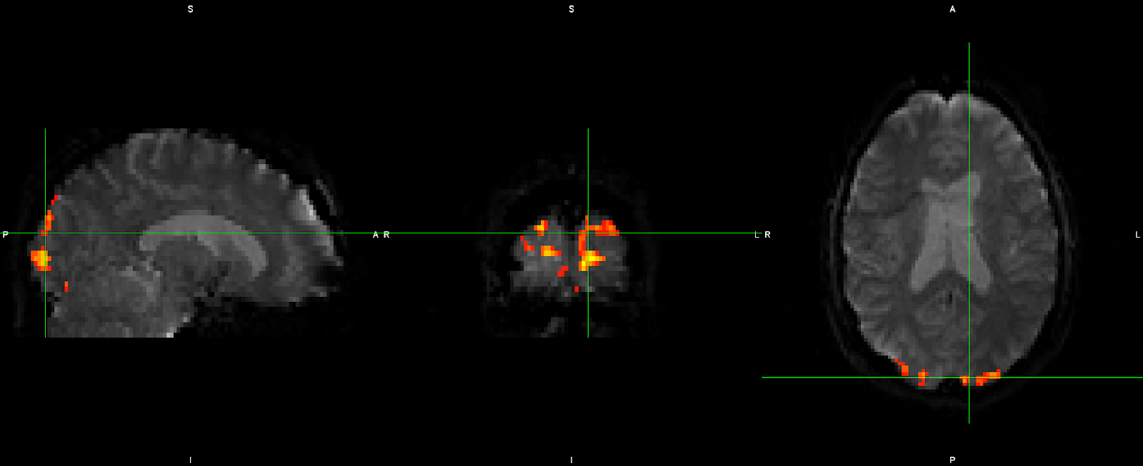

Figure 1c. Visual Activation (Z>5.14) after ICA-AROMA Motion Correction Multi-View (Patient 48)

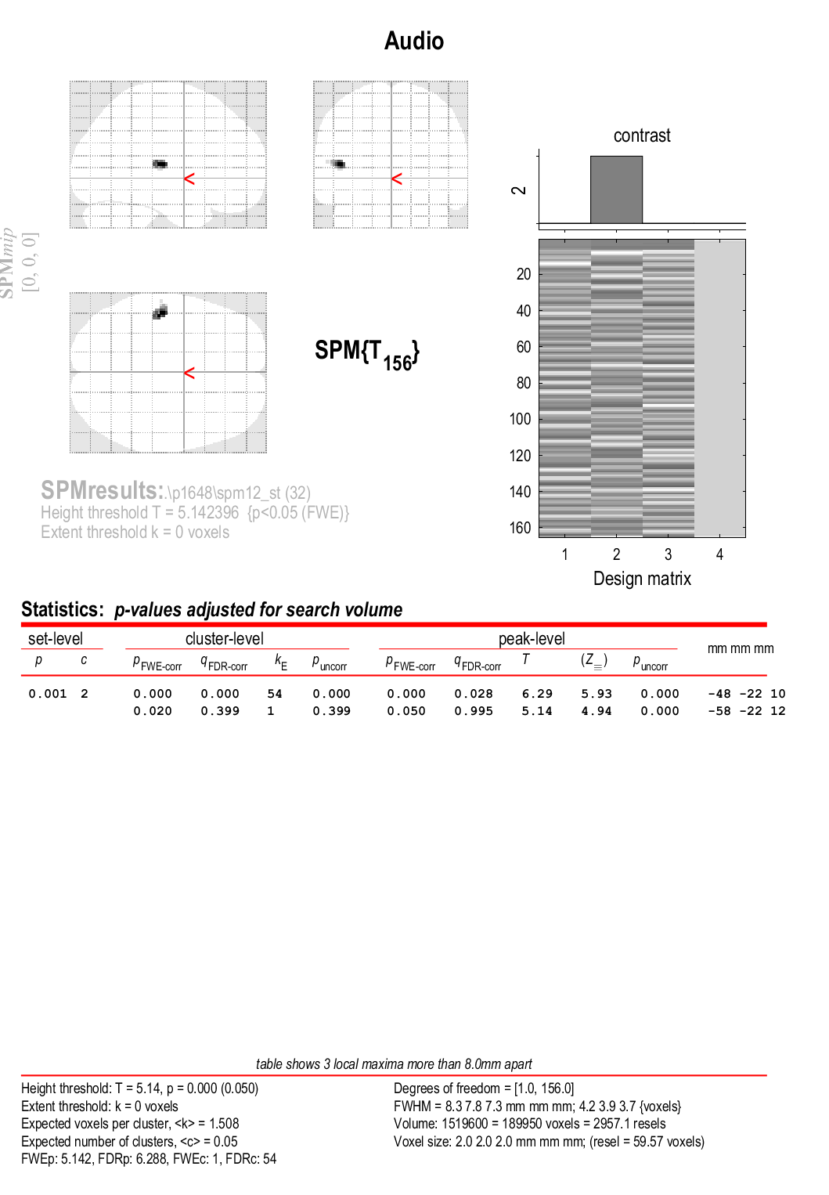

Figure 2a. Auditory Activation during Normal 1st Level Analysis (Patient 48)

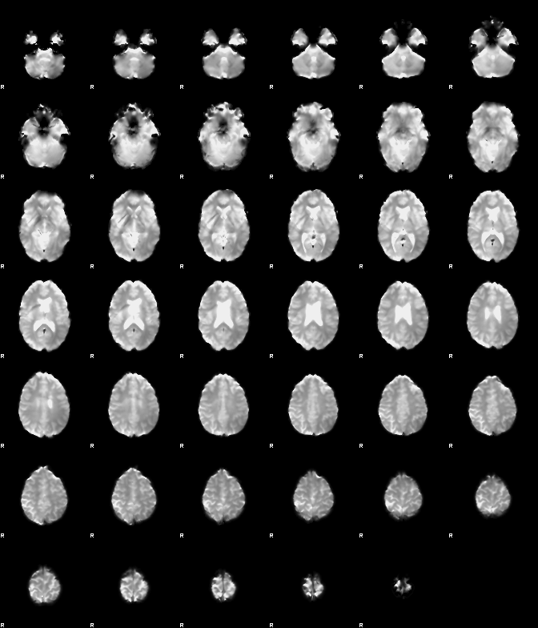

Figure 2b. Auditory Activation after ICA-AROMA Motion Correction (Patient 48)

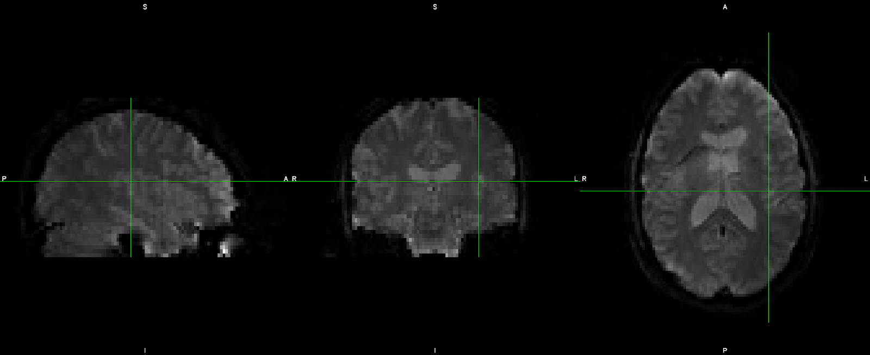

Figure 2c. Auditory (Z>5.14) Activation after ICA-AROMA Motion Correction Multi-View (Patient 48)

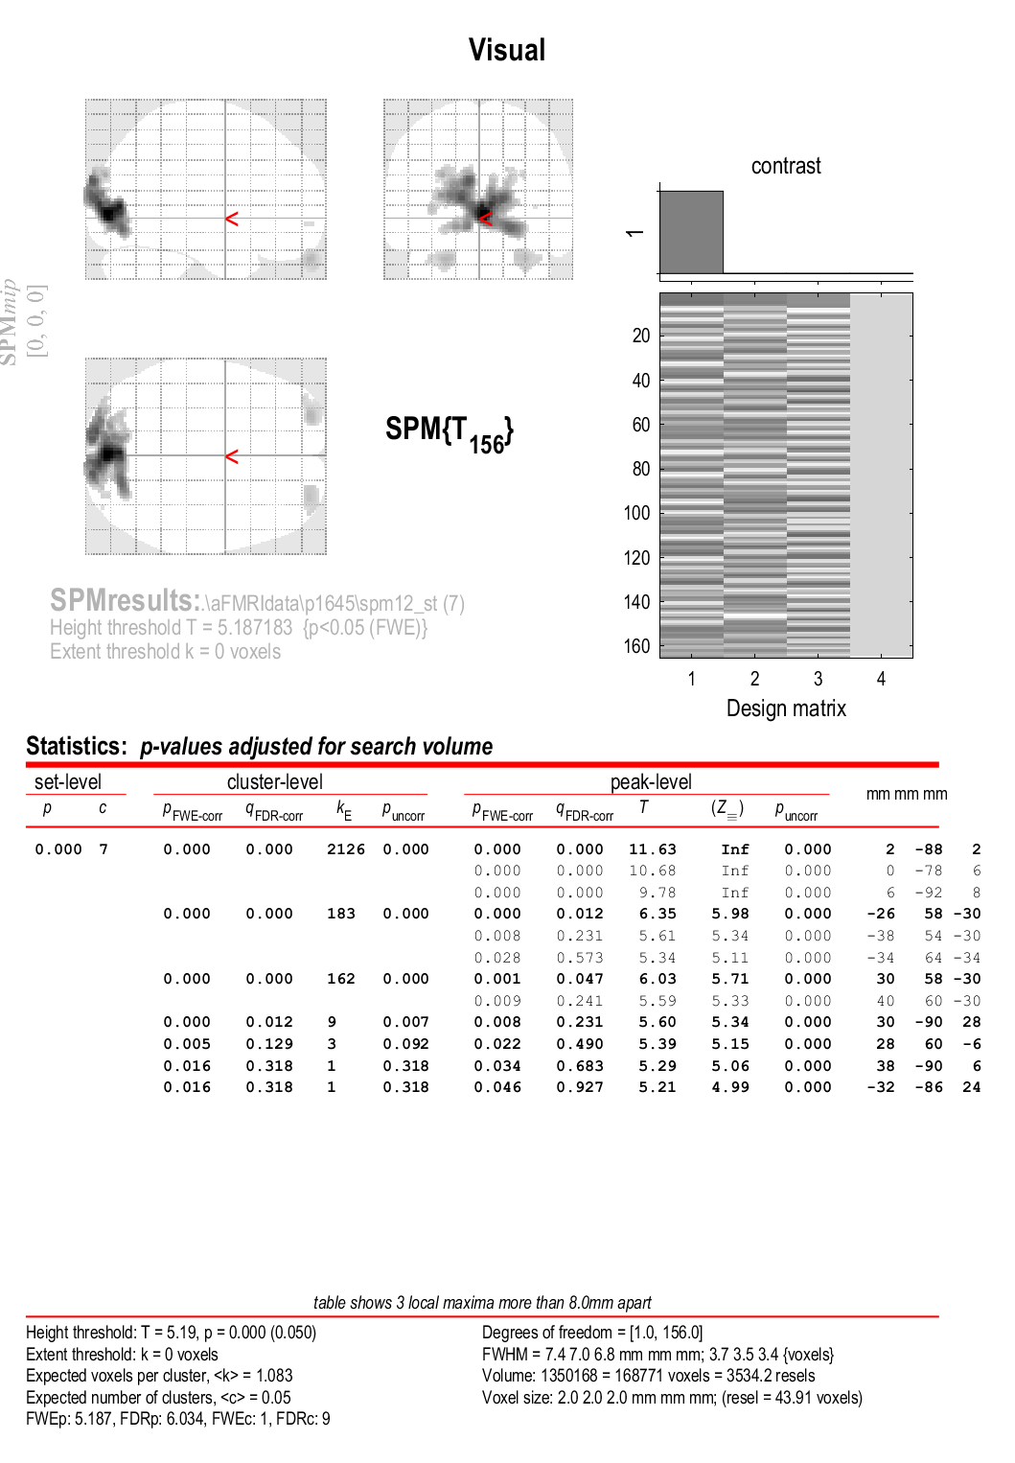

Figure 3a. Visual  Activation during Normal 1st Level Analysis (Patient 45)

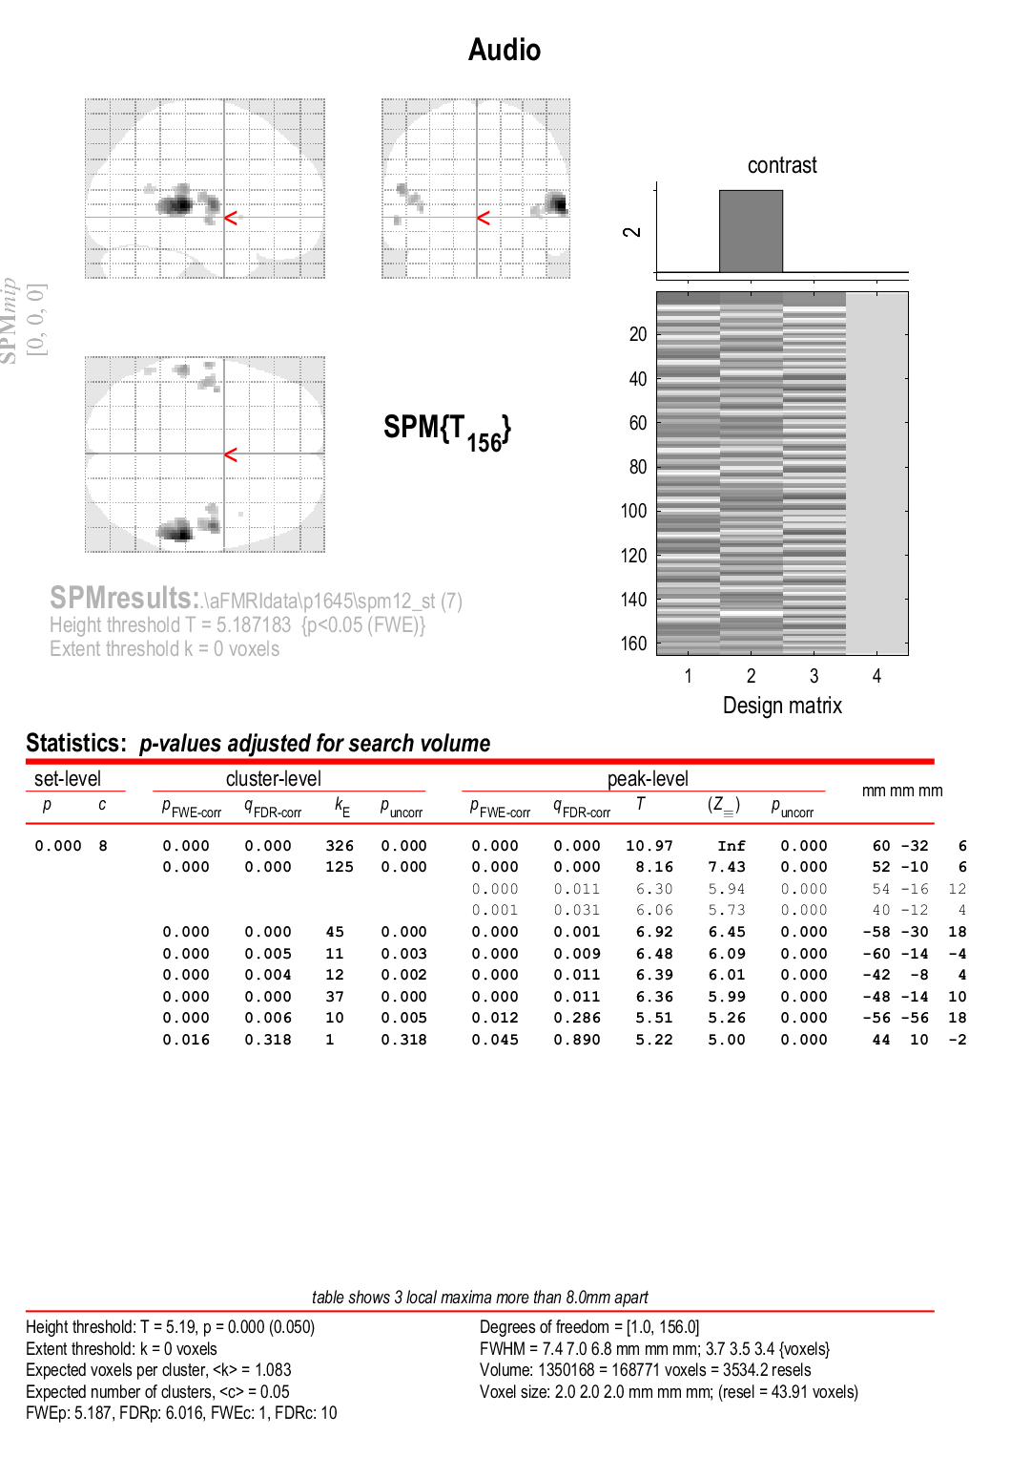

Figure 3b. Auditory Activation during Normal 1st Level Analysis (Patient 45)

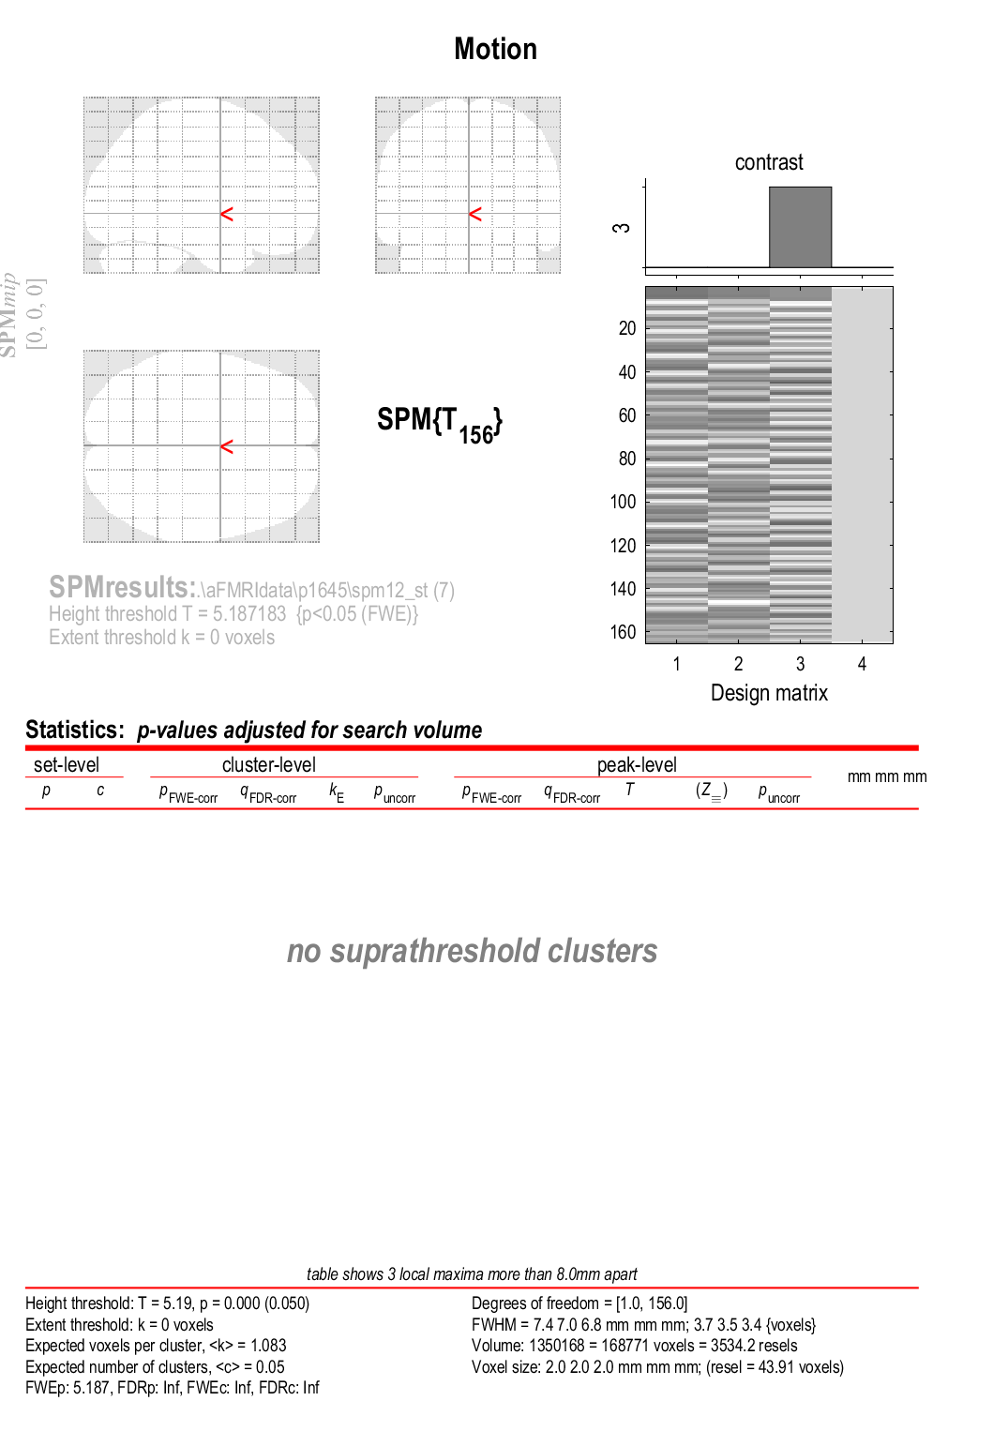

Figure 3c. Motion Activation during Normal 1st Level Analysis (Patient 45)

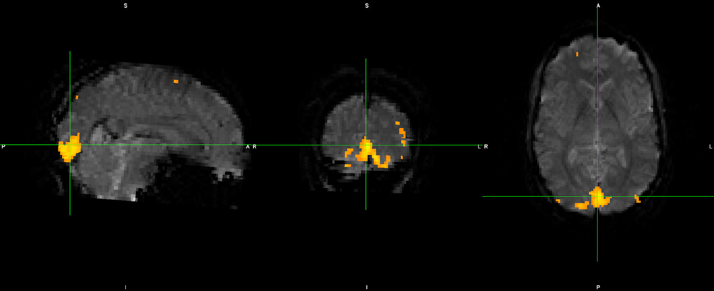

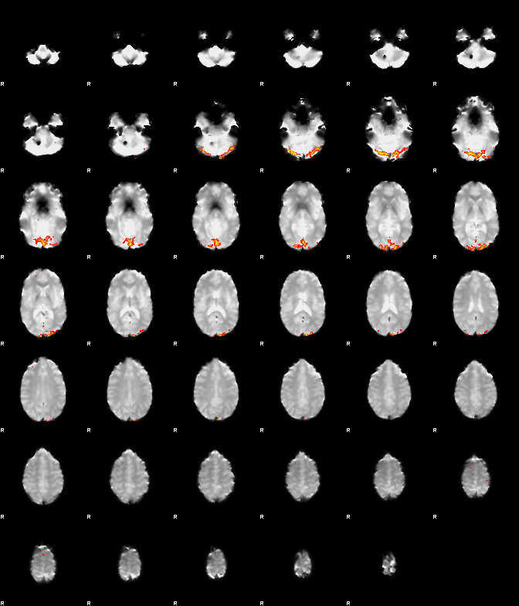

Figure 3d. Visual Activation after ICA-AROMA Motion Correction (Patient 45)

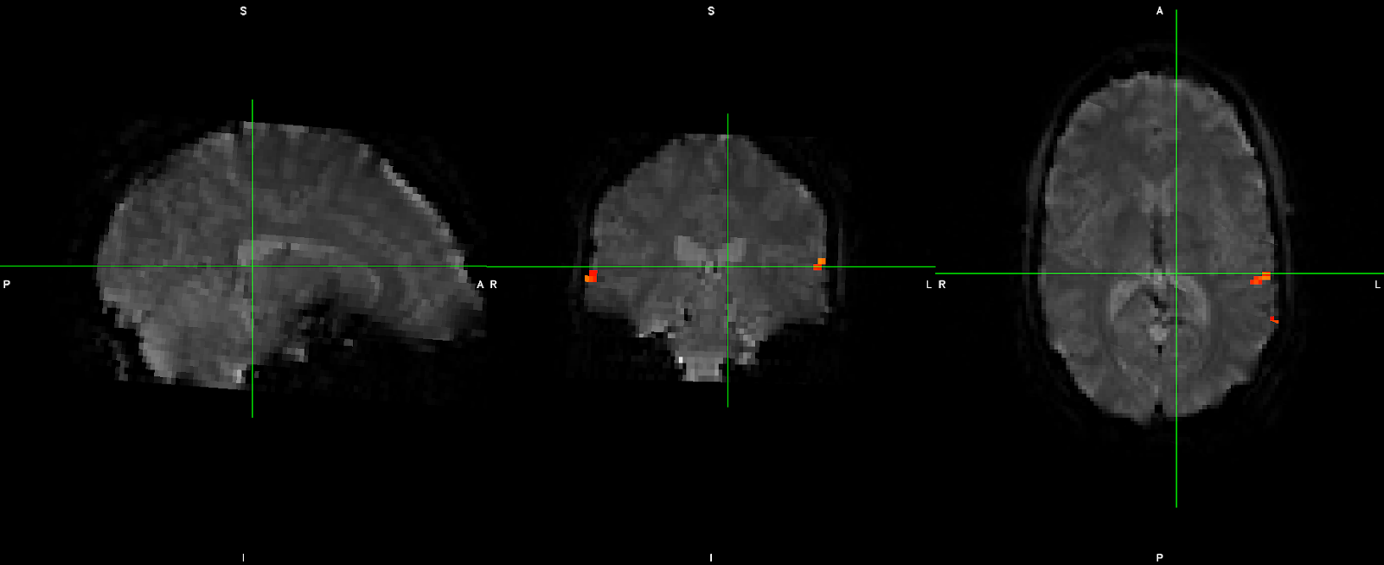

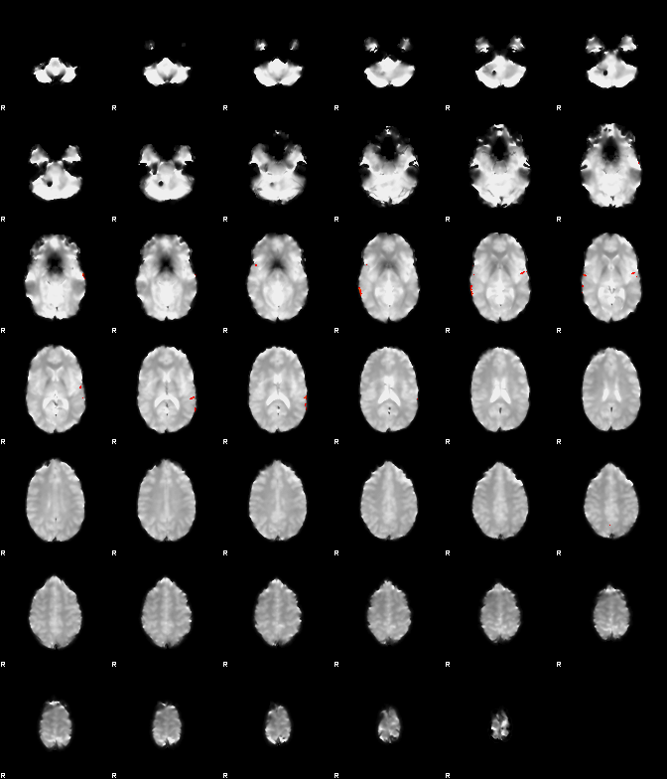

Figure 3e. Auditory Activation after ICA-AROMA Motion Correction (Patient 45)

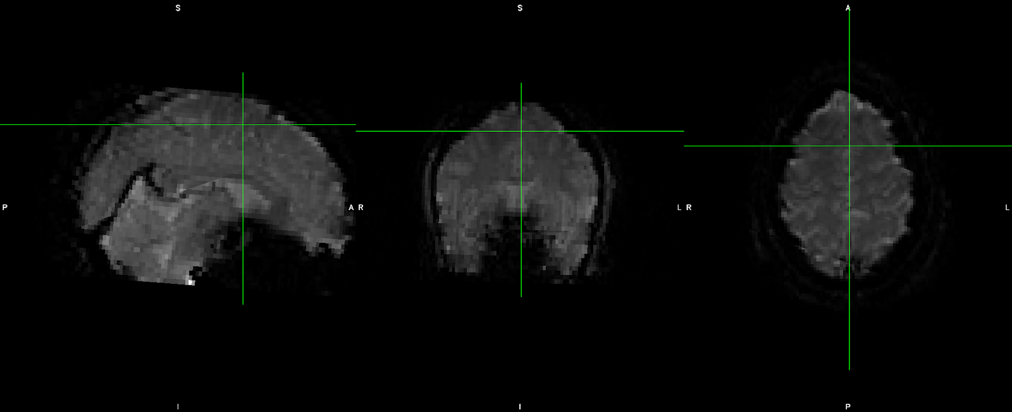

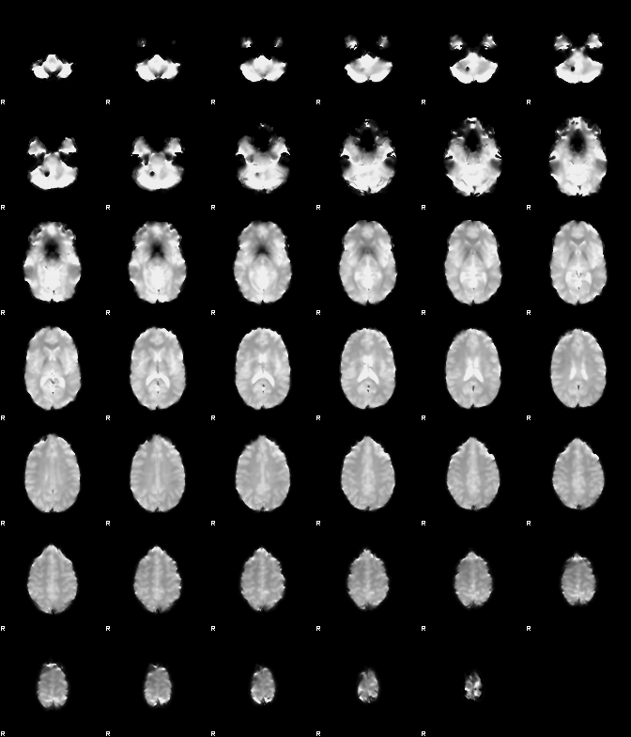

Figure 3f. Motion Activation after ICA-AROMA Motion Correction (Patient 45)

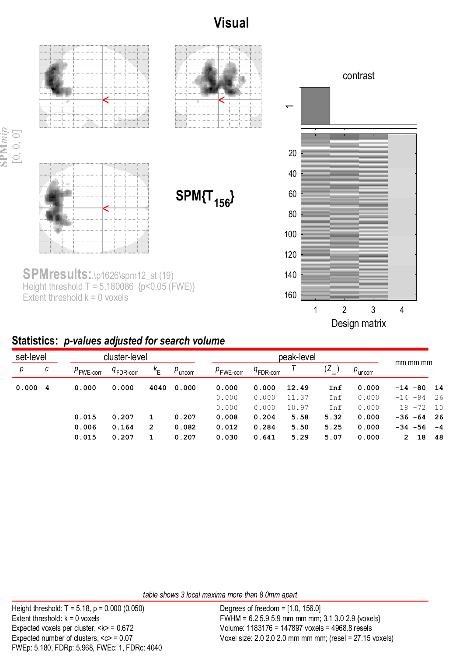

Figure 4a. Visual  Activation during Normal 1st Level Analysis (Patient 26)

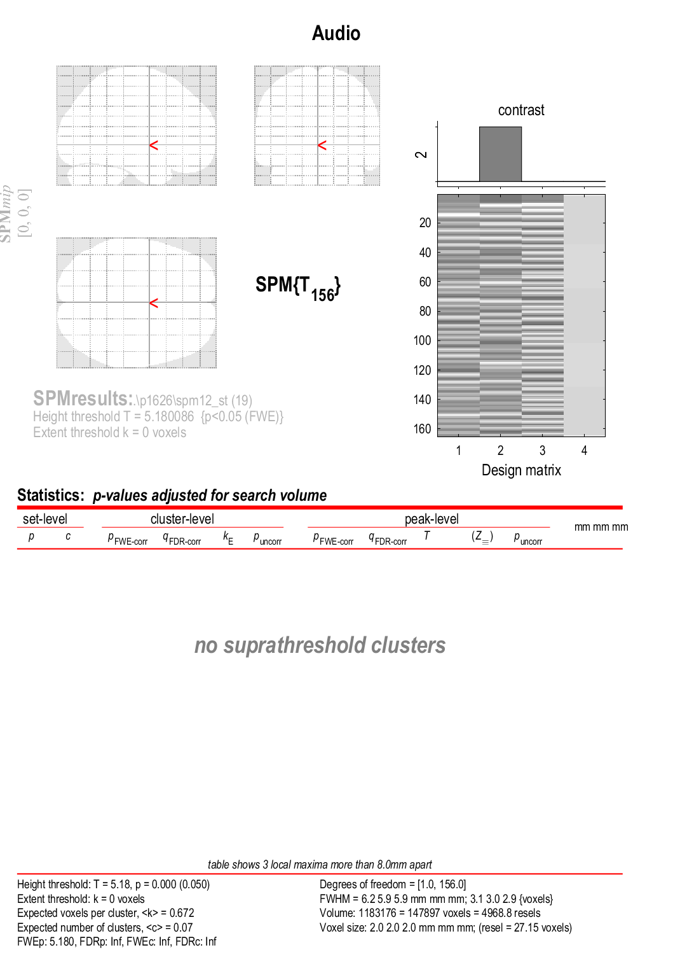

Figure 4b. Auditory  Activation during Normal 1st Level Analysis (Patient 26)

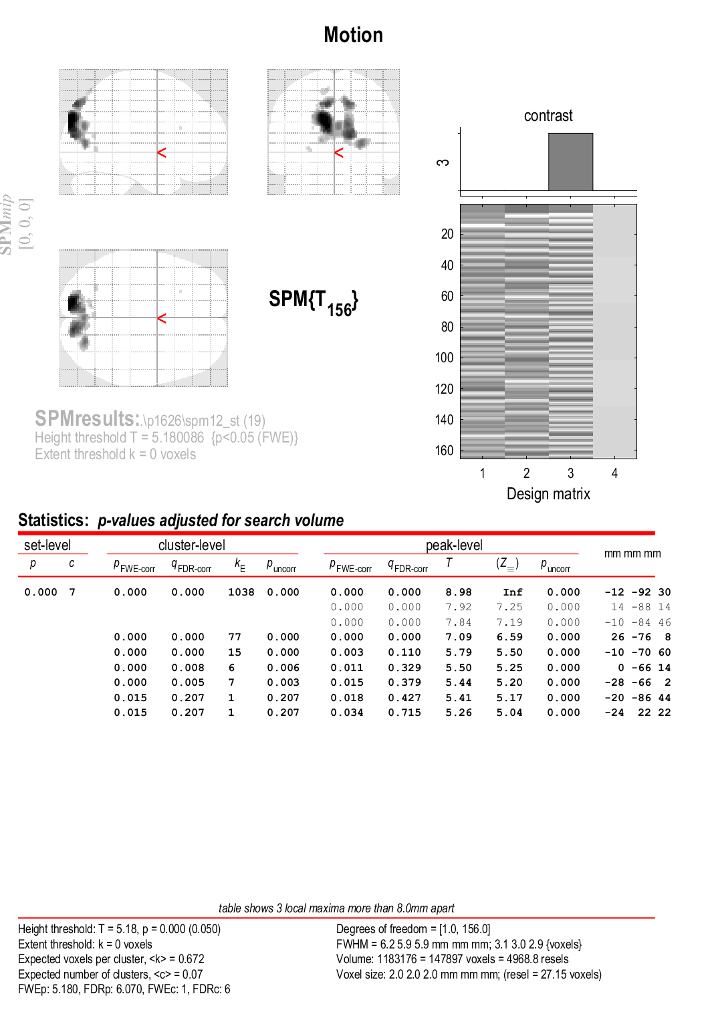

Figure 4c. Motion  Activation during Normal 1st Level Analysis (Patient 26)

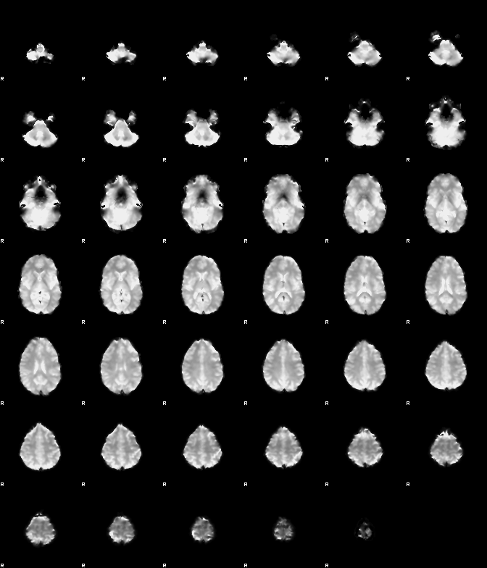

Figure 4d. Visual Activation after ICA-AROMA Motion Correction (Patient 26)



Figure 4e. Auditory Activation after ICA-AROMA Motion Correction (Patient 26)



Figure 4f. Motion Activation after ICA-AROMA Motion Correction (Patient 45)

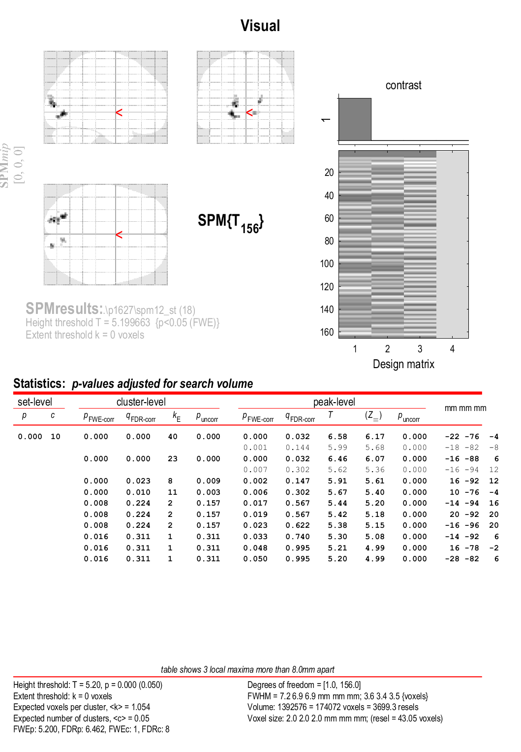

Figure 5a. Visual Activation during Normal 1st Level Analysis (Patient 27)

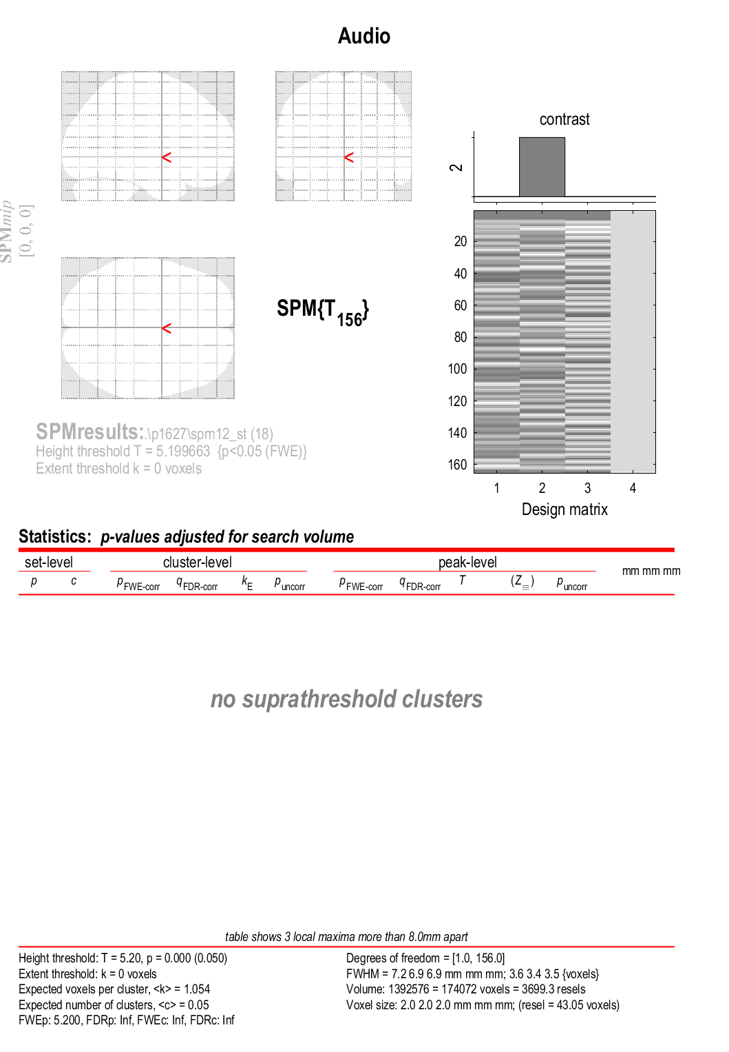

Figure 5b. Auditory Activation during Normal 1st Level Analysis (Patient 27)

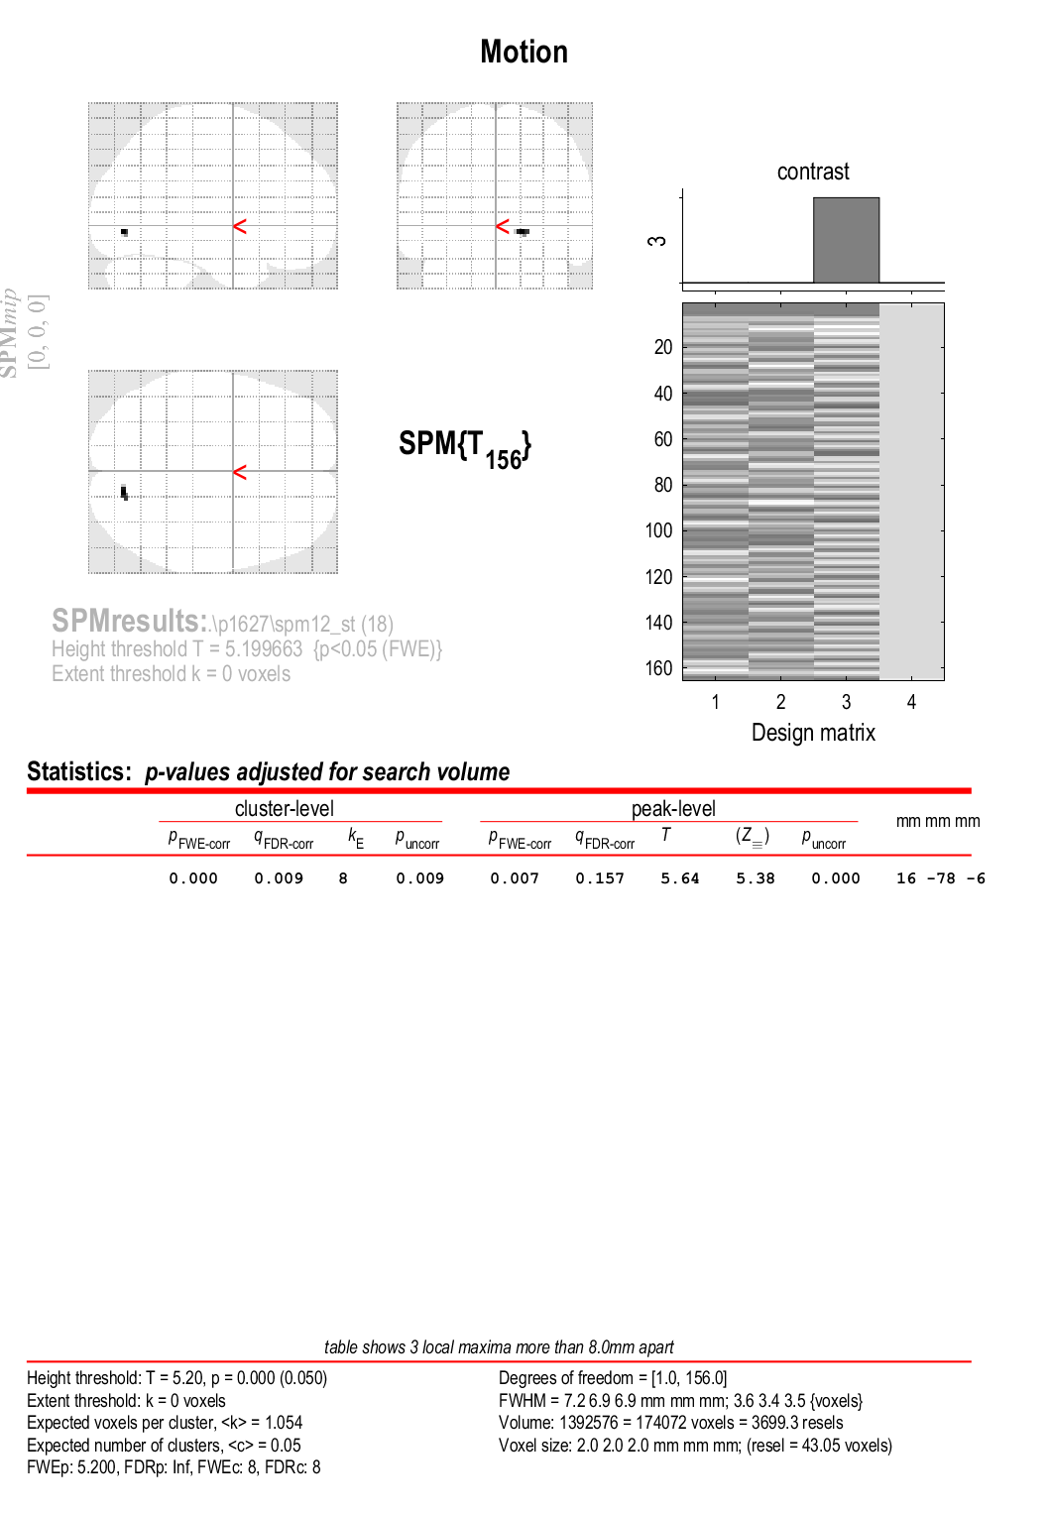

Figure 5c. Motion Activation during Normal 1st Level Analysis (Patient 27)

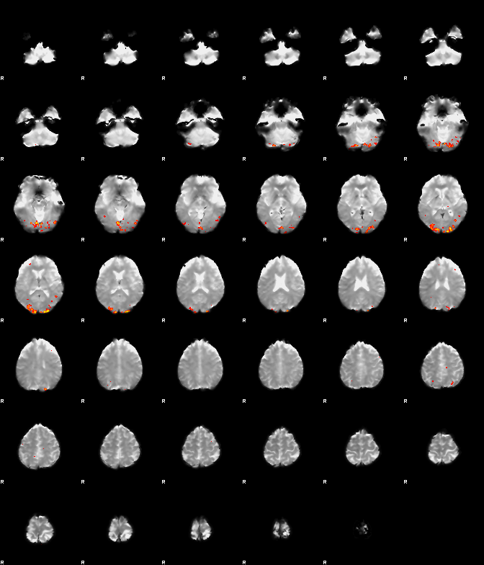

Figure 5d. Visual Activation after ICA-AROMA Motion Correction (Patient 27)

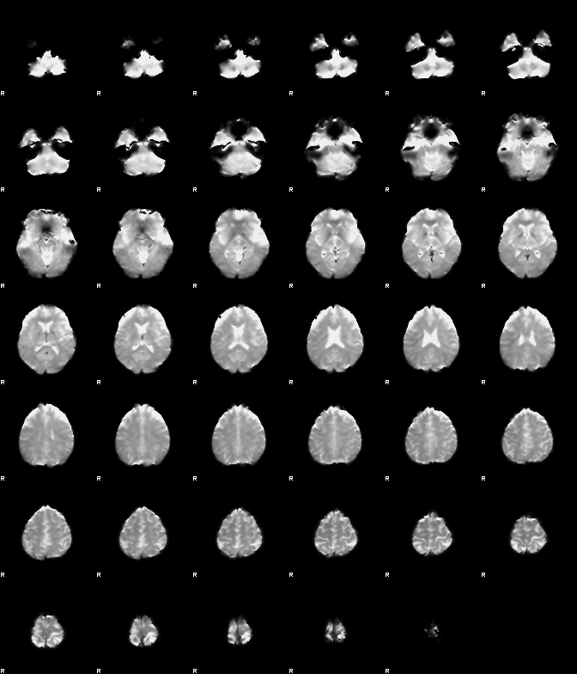

Figure 5e. Auditory Activation after ICA-AROMA Motion Correction (Patient 27)



Figure 5f. Motion Activation after ICA-AROMA Motion Correction (Patient 27)

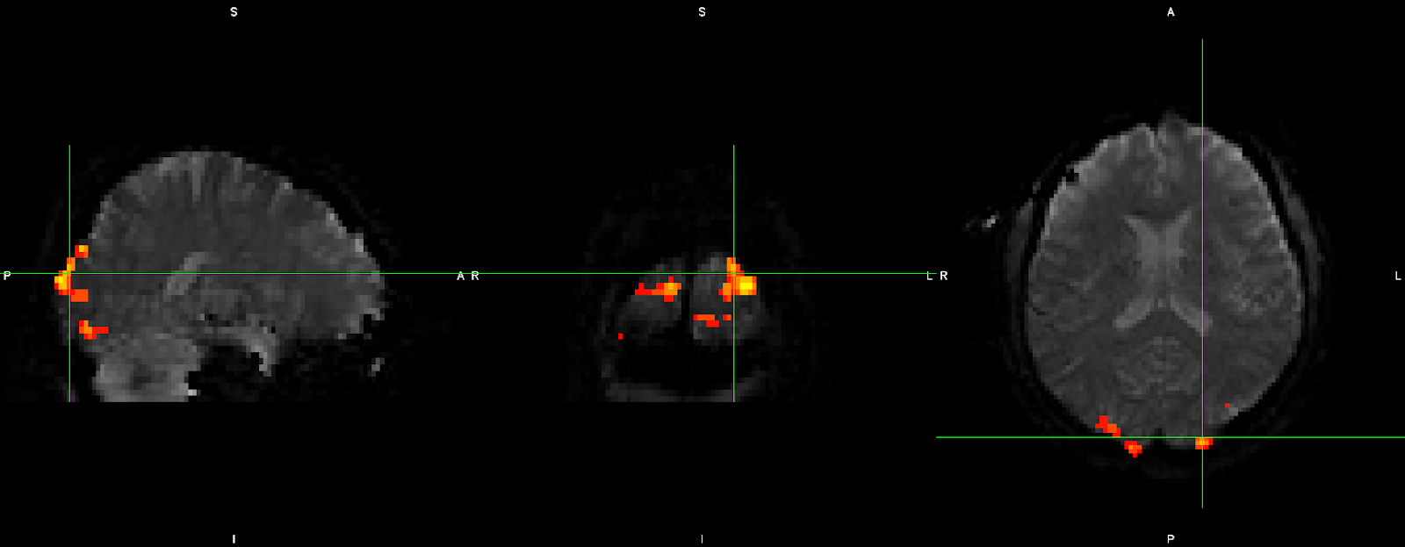

Figure 5g. Visual Activation (Z>5.2) after ICA-AROMA Motion Correction (Patient 27) Mutli-view

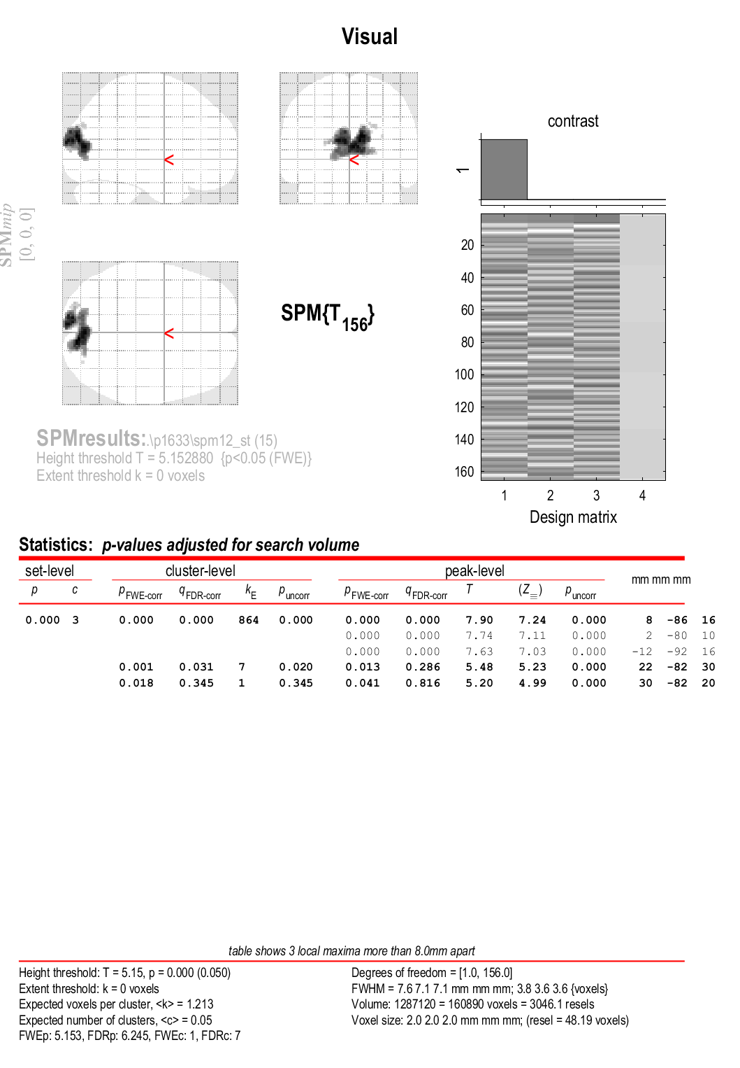

Figure 6a. Visual Activation during Normal 1st Level Analysis (Patient 33)

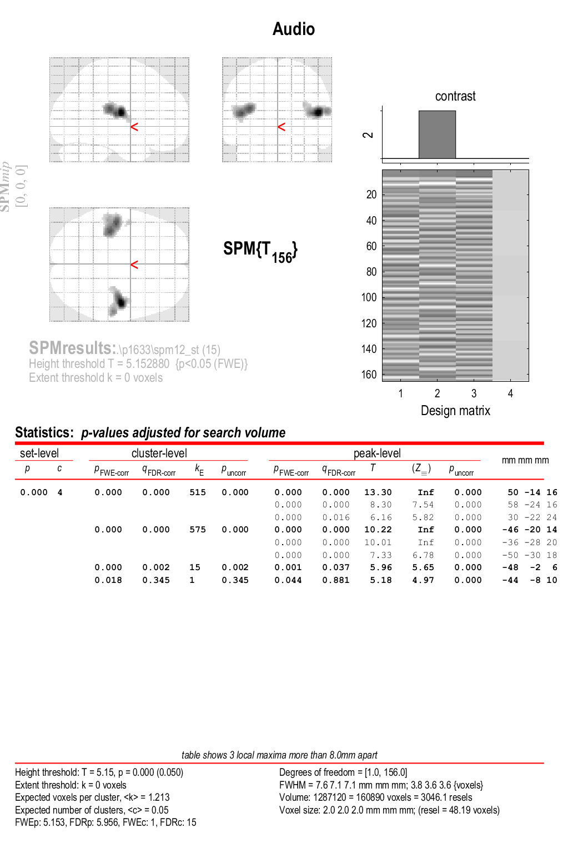

Figure 6b. Auditory  Activation during Normal 1st Level Analysis (Patient 33)

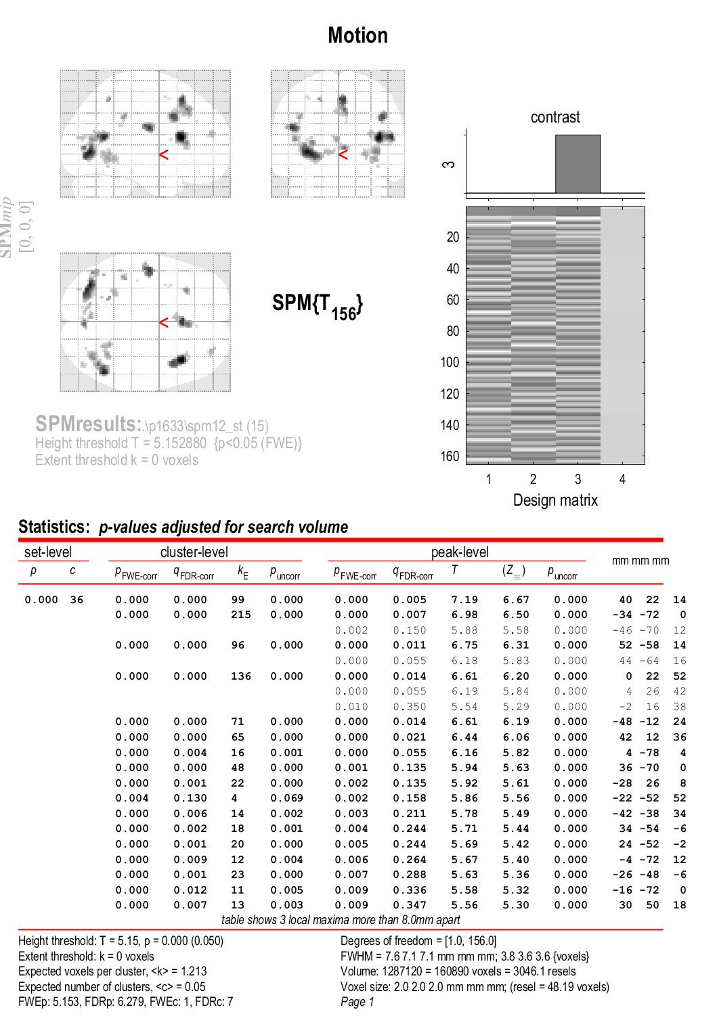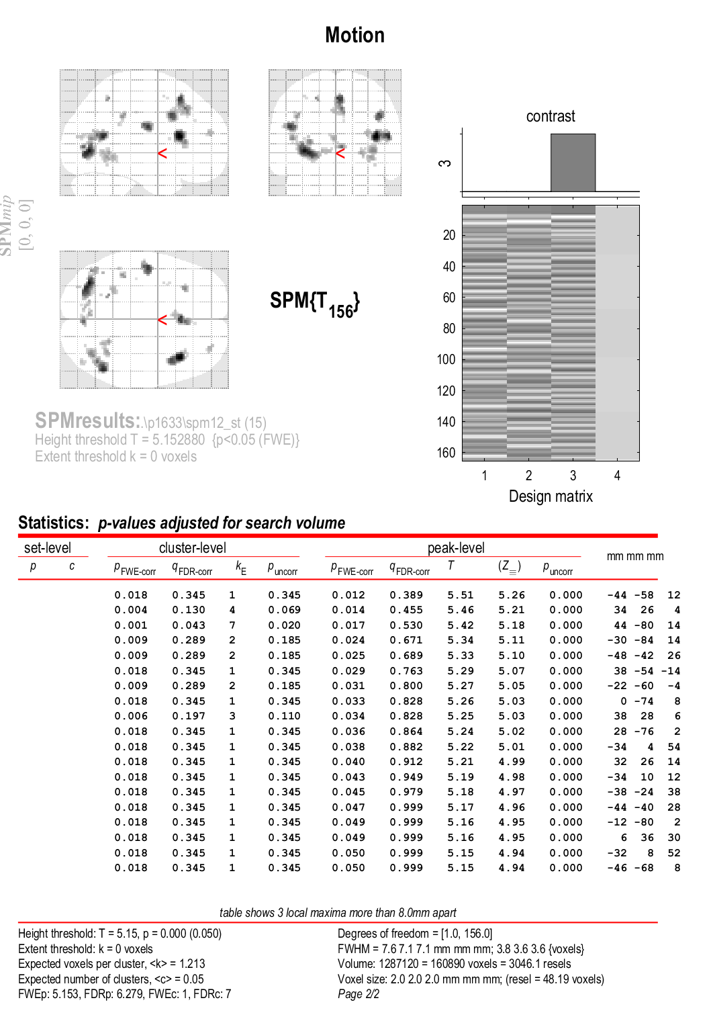

Figure 6c. Motion  Activation during Normal 1st Level Analysis (Patient 33)

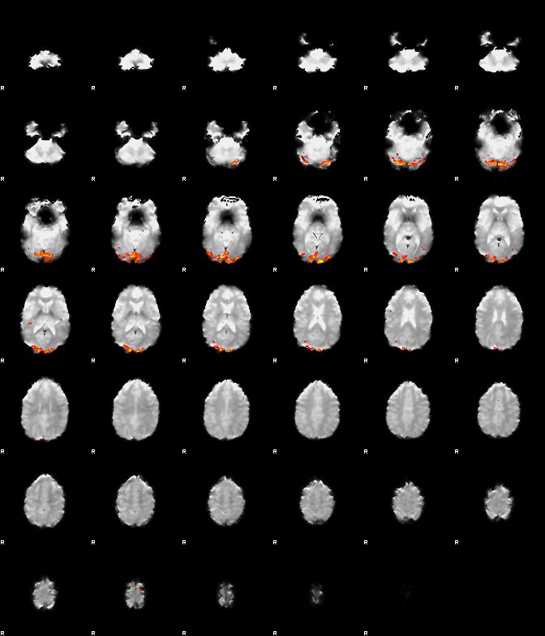

Figure 6d. Visual Activation after ICA-AROMA Motion Correction (Patient 33)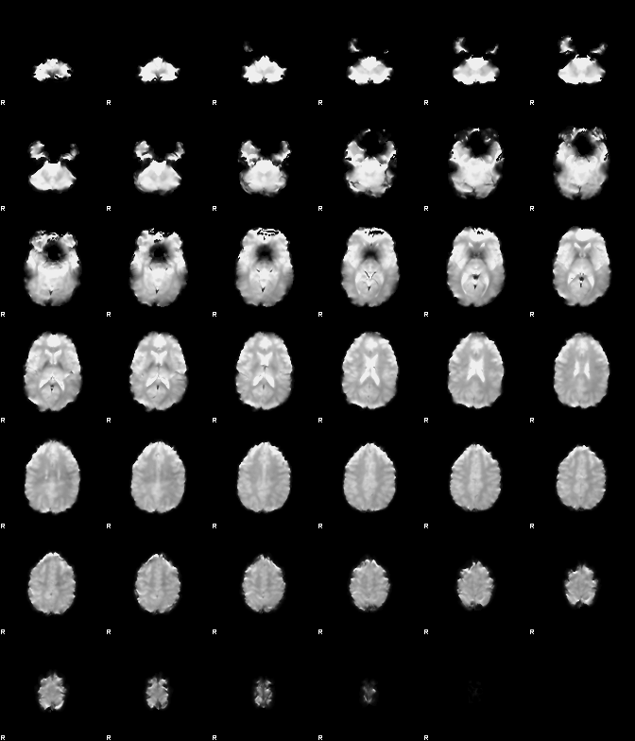

Figure 6e. Auditory  Activation after ICA-AROMA Motion Correction (Patient 33)



Figure 6f. Motion Activation after ICA-AROMA Motion Correction (Patient 33)

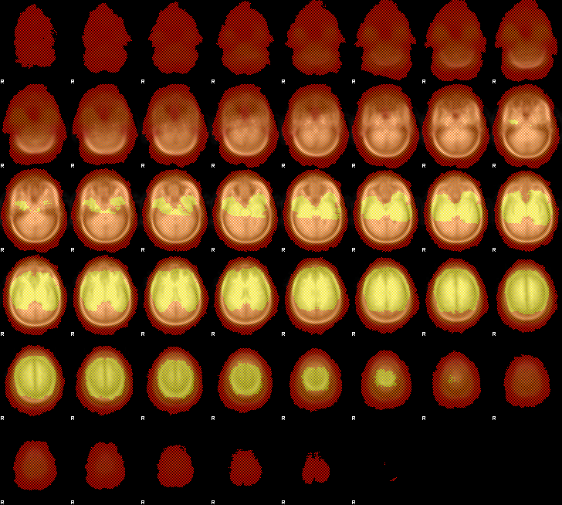

Figure 7a. Voxel-Thresholded Group Analysis Registration Overlay

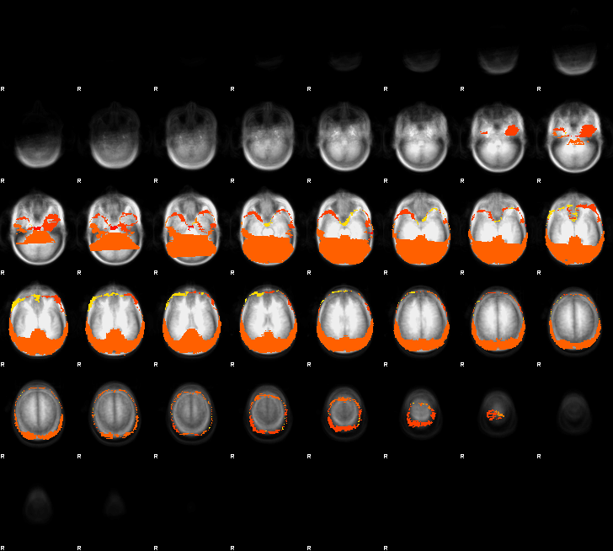

Figure 7b. Voxel-Thresholded Group Analysis Registration Missing Voxels

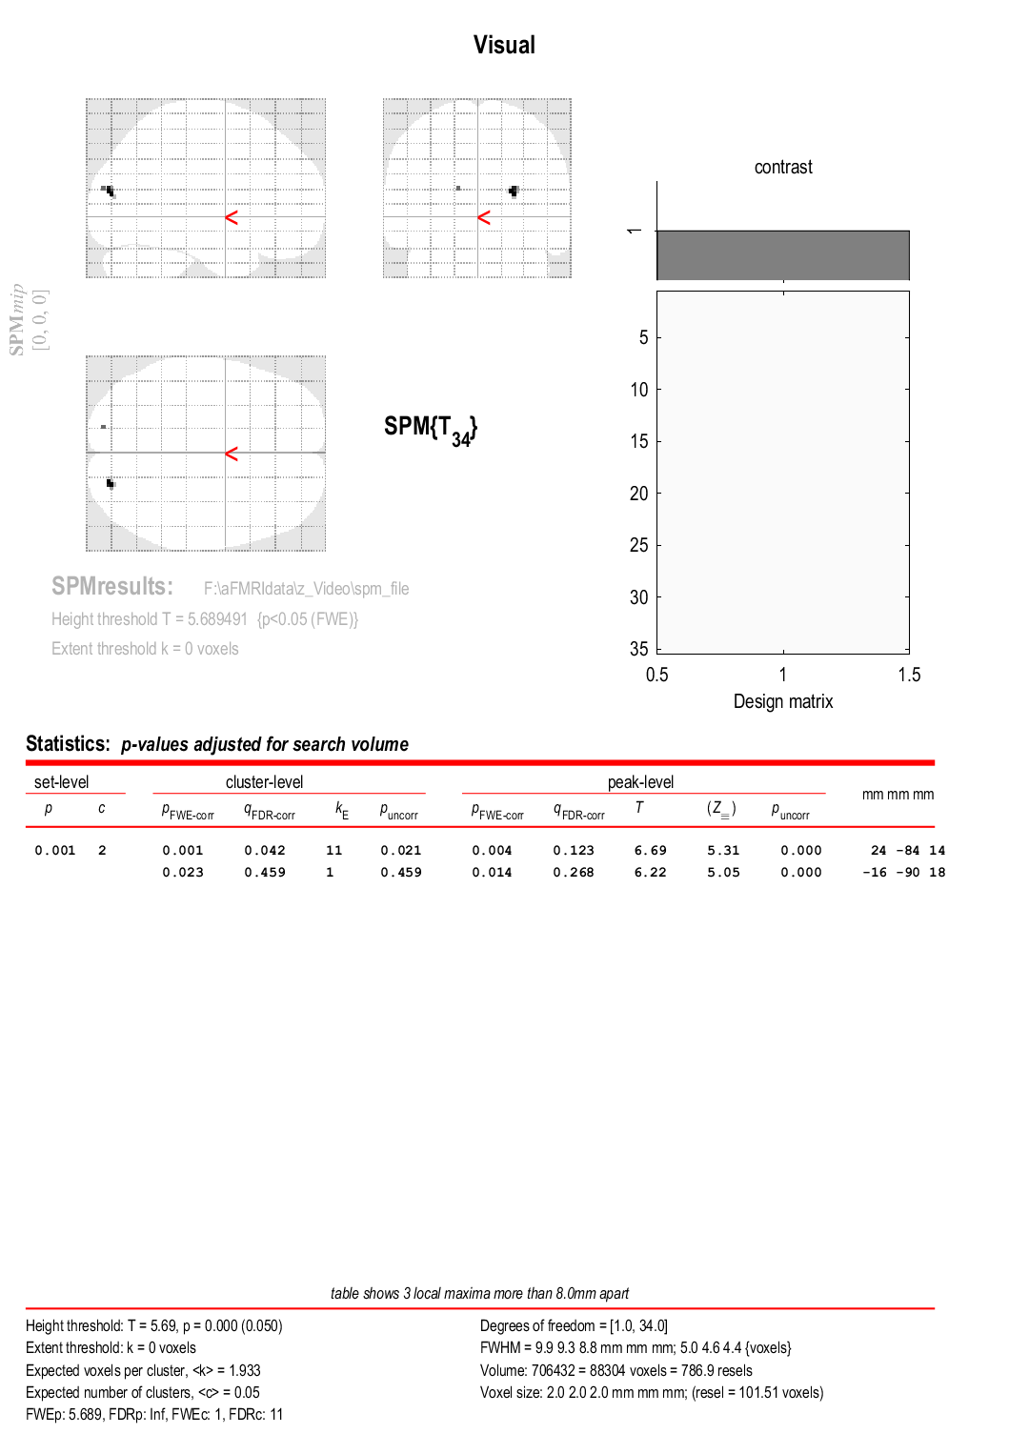

Figure 8a. Group Visual Activation Original SPM Analysis

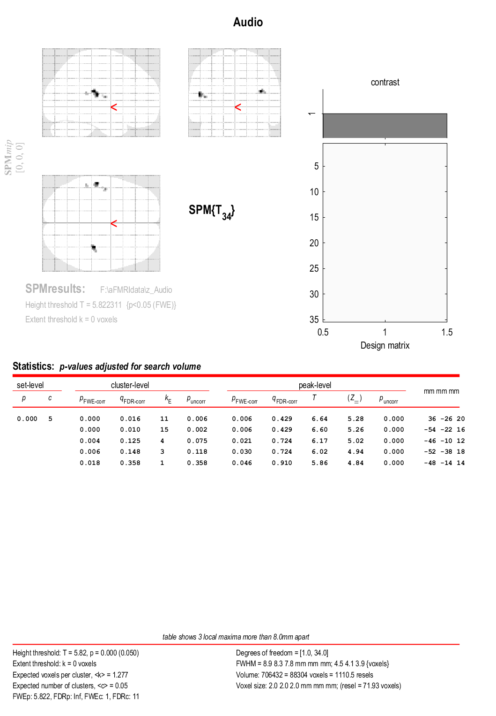

Figure 8b. Group Visual Activation Original SPM Analysis

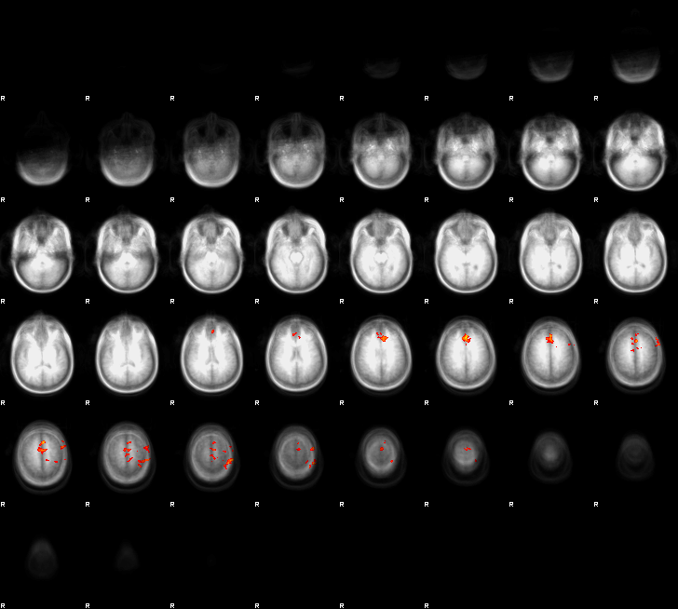

Figure 8c. Group Visual Activation after ICA-AROMA Motion Correction (Z-threshold = 2.1)

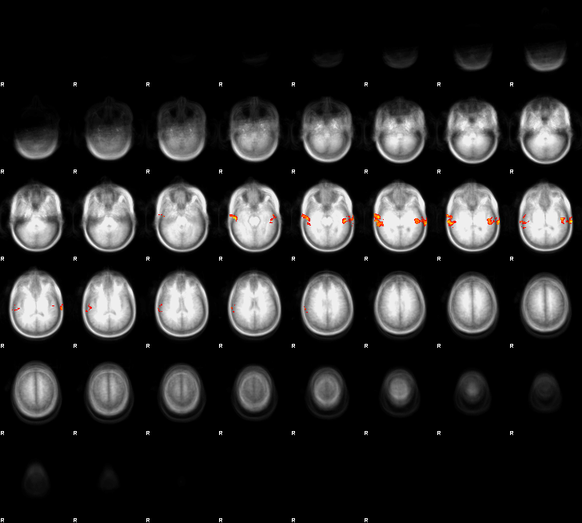

Figure 8d. Group Auditory Activation after ICA-AROMA Motion Correction (Z-threshold = 2.1)

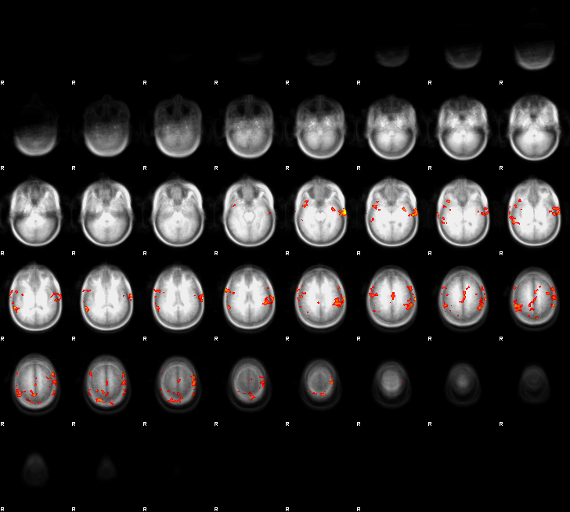

Figure 8e. Group Motion Activation after ICA-AROMA Motion Correction (Z-threshold = 2.1)